

**Project Paper**

**CSP 554: Big Data Technologies**

By

|  |  |  |
| --- | --- | --- |
| Name | A_ID | Email |
| Divyansh Soni | A20517331 | dsoni2@hawk.iit.edu |

Under the Guidance of Prof. Joseph Rosen

# 1. Introduction to the Project Use Case

Assuming we work at a small e-commerce company that sells a variety of clothes online, our customers provide feedback across all online channels. The feedback data which is product review is collected for sentiment analysis purposes. The product review on our e-commerce website can be viewed by users. The accessibility of feedback on our e-commerce website reduces the level of data privacy concerns. Since the reviews are openly available for viewing, the inherent transparency minimizes potential privacy issues associated with the review data. When we build a big data machine learning system for sentiment analysis, we may not need to be overly concerned about user privacy.

As a business, we aim to quickly capture this customer feedback to identify any changes in market trends or customer behavior and to be promptly alerted about potential product issues. Our task involves building an NLP model that takes these product reviews as input. We will use a model to classify the sentiment of the reviews into three classes: positive, neutral, and negative. The sentiment class is typically expressed as an integer value for model training, such as 1 for positive sentiment, 0 for neutral sentiment, and -1 for negative sentiment.

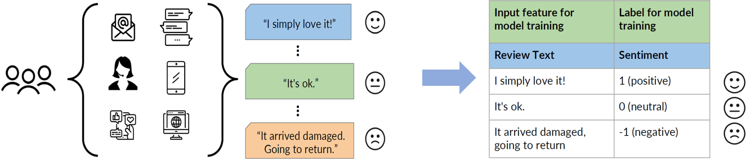

Figure 1.1 Use Case: sentiment analysis for product reviews

*Note: Figure 1.1, a portion of the illustration is obtained from the internet and recreated by Divyansh Soni*

In this case, we are attempting to ascertain whether a particular product review is positive (1), neutral (0), or negative (-1). We have three distinct classes that we aim to predict. Therefore, in this scenario, we are dealing with a classification problem—specifically, the classification of reviews into categories, which is a common text classification task. Text analysis, or natural language processing (NLP), has been around for a long time. In fact, early work dates back to the late 1940s and the early 1950s, and there have been significant advancements over the last decade (Feng, Z, 2023). However, the field has experienced tremendous progress, primarily driven by the evolution and improvement of machine learning algorithms for text analysis.

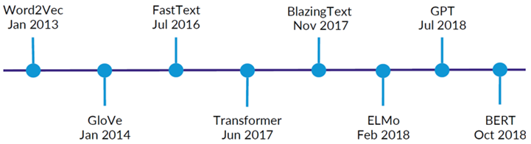

Figure 1.2 Recent Evolution of ML Algorithms for Text Analysis

We have decided to adopt the latest NLP algorithm and develop a big data machine learning system. Our approach involves building a natural language processing model based on BERT.

# 2. Technologies for the Big Data Machine Learning System

In this section, we will delve into technologies and solutions of constructing a Big Data Machine Learning system using AWS SageMaker. This section provides a comprehensive understanding of the tools and techniques essential for constructing an efficient Big Data Machine Learning system for product review sentiment analysis.

## 2.1 Comparative Analysis of Popular End-to-End ML Platforms

There are several popular end-to-end machine learning platforms that are widely used for developing big data machine learning systems such as Amazon SageMaker, Google Cloud Machine Learning Engine (GCP ML Engine), and Microsoft Azure Machine Learning (Azure ML). End-to-end machine learning platforms provide a unified environment for managing the entire machine learning lifecycle, from data preparation and model development to deployment and monitoring (Brumbaugh, Eli, et al, 2019). This can help to streamline the development process and make it easier to build and deploy big data machine learning systems. Amazon SageMaker, Google Cloud Machine Learning Engine (GCP ML Engine), and Microsoft Azure Machine Learning (Azure ML) are all cloud-based machine learning (ML) platforms that provide a set of tools and services to build, train, and deploy machine learning models. Here is a brief comparison of the 3 popular cloud-based platforms for developing and deploying machine learning models.

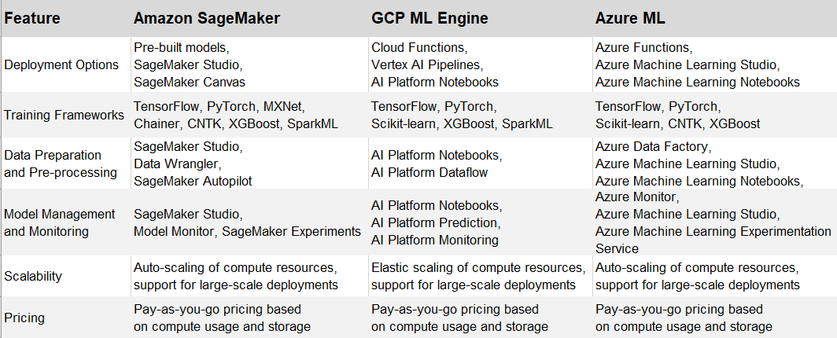

Figure 2.1.1 Comparison of the Popular Cloud-based ML Platforms

*Note: Figure 2.1.1 created in Excel by Divyansh Soni after reviewing technical blogs and the official websites.*

In the brief comparison, we found that there is no definitive best end-to-end machine learning platform, as all platforms offer comparable features. After carefully considering the three industrial popular cloud machine learning platforms and taking into account our existing familiarity with the Amazon Web Services environment, we have decided to use Amazon SageMaker for developing the product review sentiment analysis big data machine learning system.

## 2.2 Comparative Analysis of Popular AI Frameworks

When it comes to AI frameworks for implementing a big data machine learning system, there are two popular frameworks available for various supervised and unsupervised machine learning tasks, including but not limited to image classification, computer vision, and speech processing. TensorFlow and PyTorch are both popular deep learning frameworks that are widely used for natural language processing (NLP). Here we briefly introduce and compare the popular AI frameworks based on the information on the official websites.

(1) TensorFlow:

TensofFlow is developed by Google, It is an open-source machine learning framework widely used for tasks such as deep learning, neural network implementations, and numerical computations (Wikipedia, 2023). TensorFlow also has a large and active community, which means that there are many resources available to help us get started .

(2) PyTorch:

PyTorch developed by Facebook's AI Research lab (FAIR), is known for its dynamic computational graph, making it popular for research in deep learning and natural language processing (Wikipedia, 2023). PyTorch also has a growing community, and there are many resources available to help us learn the framework.

Each framework has its own strengths and weaknesses. Below is a brief comparison of TensorFlow and PyTorch based on information from the official websites and reviews from various technical blogs.

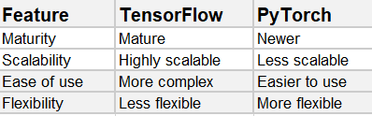

Figure 2.2.1 Comparison of the Popular ML Frameworks

*Note: Figure 2.2.1 was created in Excel by Divyansh Soni after reviewing some technical blogs and the official websites.*

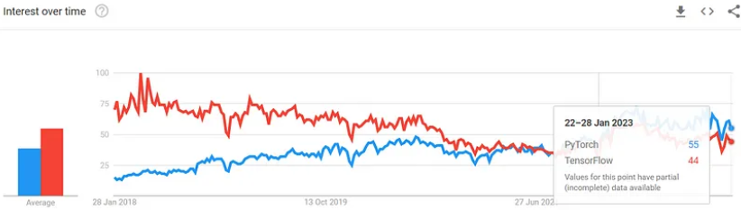

Figure 2.2.2 Comparison of the Popular ML Frameworks (K, Valantis, 2023)

PyTorch and TensorFlow have experienced significant increases in popularity, likely attributed to the emergence of transfer learning and the availability of pre-trained models offered by Hugging Face. Nevertheless, it appears that PyTorch boasts superior model availability (K, Valantis, 2023) for big data machine learning. After comparing two popular AI frameworks, we have determined that PyTorch is the most suitable choice for building the big data machine learning system for product review sentiment analysis, considering our priorities for flexibility and ease of use.

## 2.3 Comparative Analysis of Toolkits for Data Profiling

Except for these popular machine learning frameworks, there is a popular machine learning library called Spark MLlib. Spark MLlib is the machine learning library provided by Apache Spark, an open-source distributed computing system (Apache Spark, 2023). MLlib is designed to work seamlessly with Spark and enables scalable and distributed machine learning on large datasets. It provides various algorithms and tools for machine learning tasks, including classification, regression, clustering, and collaborative filtering. In comparison to Amazon SageMaker within the Amazon Web Services ecosystem, and considering our existing familiarity with the Amazon Web Services environment and its ease of use feature, we have opted to utilize AWS Glue and AWS Athena which are supported in SageMaker platform for data profiling on the product review dataset. Below is a brief comparison was created in Excel by Divyansh Soni after reviewing some technical blogs and the official websites.

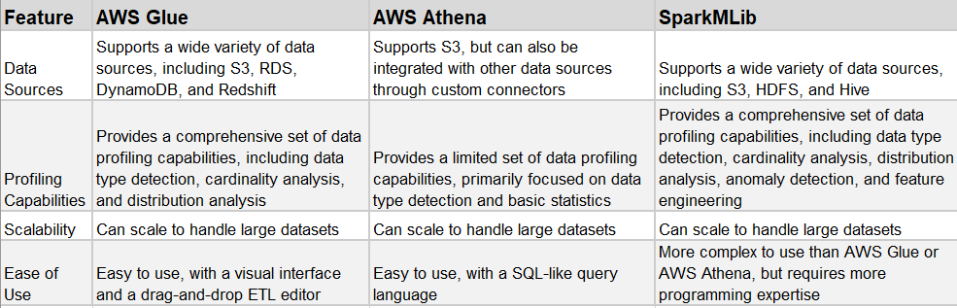

Figure 2.3.1 Comparison of the Toolkits for Data Profiling

*Note: Figure 2.3.1 was created in Excel by Divyansh Soni after reviewing some technical blogs and the official websites.*

There are two useful Amazon Cloude Services in the end-to-end ML platform (Amazon SageMaker) that we can use to detect statistical bias—one focus of data profiling—with AWS Glue and AWS Athena: Amazon SageMaker Data Wrangler and Amazon SageMaker Clarify.

(1) Amazon SageMaker Data Wrangler

Data Wrangler provides us with the capability to connect to various data sources, visualize data, and transform data by applying numerous transformations within the Data Wrangler environment (AWS, 2023). It enables us to detect statistical bias in datasets and generate reports regarding the detected bias. Additionally, it offers capabilities to perform feature importance calculations on the training dataset. Data Wrangler provides us with more of a UI-based visual experience. Data Wrangler is only using a subset of the data to detect bias in that dataset.

(2) Amazon SageMaker Clarify

Amazon SageMaker Clarify serves as a tool for conducting statistical bias detection on datasets. It has the capability to detect statistical bias and generate bias reports for training datasets (AWS, 2023). Moreover, it can identify bias in both trained and deployed models. In addition, SageMaker Clarify provides features for machine learning explainability and can detect drift in both data and models. It adopts more of an API-based approach and allows us to scale out the bias detection process. Specifically, Clarify employs a construct known as processing jobs, enabling us to configure a distributed cluster for executing the bias detection job at scale.

In comparison, we have chosen to use SageMaker Clarify for bias detection.

# 3. Data Preparation and Profiling

In Section 3, we analyze pivotal aspects of data transformation, bias, and imbalance within the product review sentiment analysis big data machine learning project. With a processed dataset focusing on 'review_body,' 'product_category,' and 'sentiment,' we explore potential biases and imbalances that could impact model performance. Our focus lies on class imbalance and the Difference in Proportions of Labels (DPL) metric, addressing disparities in product category ratings. Additionally, we emphasize the significance of data profiling, advocating for the use of AWS Glue and AWS Athena over traditional tools. This section unveils a comprehensive analysis of sentiment data distribution, guiding us towards a nuanced understanding of the dataset's dynamics for more informed big data machine learning model development.

## 3.1 Data Transformation, Bias and Imbalance

In the product review dataset, comprising 10 features, we selected three features highly relevant to product reviews. Subsequently, we transformed the data into a comma-separated values (CSV) file, including only the 'review_body,' 'product_category,' and 'sentiment,' derived from the original dataset.

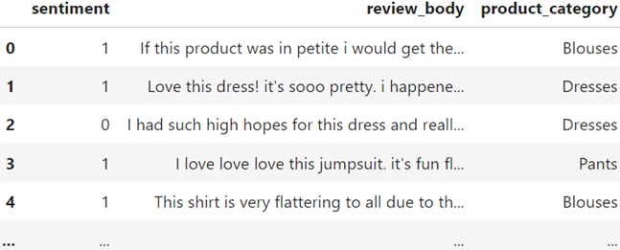

Figure 3.1.1 Data Transformation (*Created by Divyansh Soni through code implementation*)

A dataset is deemed biased if it cannot fully and accurately represent the underlying problem space. The product review dataset could be statistically biased if it contains a disproportionately large number of reviews for one product category. Statistical bias refers to the tendency of a statistic to either overestimate or underestimate a parameter, reflecting imbalances in these training datasets (Black, Anne C., et al, 2011). The imbalances in training datasets potentially lead to suboptimal model performance and skewed results. Imbalances can lead to biased model training, where the model may exhibit a preference for the majority class, as it is more heavily represented in the training data (Branco, Paula, et al, 2017). There are several metrics that can be used to measure different portions of bias across the datasets. In this big data machine learning project, we have chosen to focus on detecting imbalances in the training dataset, given that this machine learning system is designed for text classification. The first metric is a class imbalance, which refers to an unequal distribution of instances among different classes in a classification dataset (Luque, Amalia, et al, 2019). When we apply the class imbalance metric to the product review dataset, it addresses this specific question: Is there a significantly higher number of total reviews for a specific product category compared to any other category in the dataset? The second metric we adopt is Difference in Proportions of Labels (DPL). The Difference in Proportions of Labels (DPL) is a metric that can be used to quantify disparities in the distribution of class labels across different groups or subpopulations within a dataset (Das, Sanjiv, et al, 2021). It's particularly relevant in scenarios where we want to assess if there are significant differences in the prevalence of certain outcomes among different groups.



where P1 and P2 are the proportions of positive outcomes in two different groups, we aim to employ DPL (Disproportionate Impact on Ratings) on the product review dataset to assess whether a specific product category exhibits ratings that are disproportionately higher than those in other categories.

## 3.2 Data Profiling

Data profiling is the process of examining and summarizing data to understand its structure, content, and quality (Wikipedia, 2022). It is a crucial step in data analysis and machine learning, as it helps to identify potential problems with the data before it is used for modeling or decision-making. There are three key benefits of data profiling (Wikipedia, 2022):

1. Improved data quality: Data profiling can help to identify and correct errors and inconsistencies in data, which can improve the accuracy of downstream analysis.
2. Increased understanding of data: Data profiling can provide insights into the structure and content of data, which can help to inform data modeling and decision-making.
3. Reduced risk of bias: Data profiling can help to identify potential biases in data, which can help to prevent biased outcomes in machine learning models.

Data profiling can be performed using a variety of tools and techniques, and the specific steps involved will vary depending on the type of data and the goals of the analysis. The toolkits for data profiling we’ve discussed in section 2.3. In the big data machine learning system for product review sentiment analysis, we choose to understand and prepare data for model training by focusing on comprehending sentiment data distribution (3.2.2 Sentiment Data Distribution), detecting bias (3.2.3 Bias Detection), and determining feature importance (3.2.4 Feature Importance).

### 3.2.1 Rethinking Data Profiling: The Limitations of Pandas and Numpy

When dealing with big data in a machine learning system, it’s not recommended to utilize pandas, numpy to do data profiling. The libraries of pandas, numpy have limitations when dealing with big data (Singh, Aishwarya, 2018).

**Pandas Limitations**

1. Memory Overhead: Pandas dataframes can consume significant memory, especially when dealing with large datasets. This can pose challenges for profiling operations on memory-constrained systems.
2. Limited Data Types: Pandas natively supports a limited range of data types, such as integers, floats, and strings. This can restrict profiling capabilities for non-standard or complex data types.
3. Data Type Inference Issues: Pandas may misinterpret data types, leading to profiling inconsistencies. For instance, numerical data might be inferred as categorical, affecting profiling accuracy.
4. Handling Missing Values: Pandas' handling of missing values can complicate profiling tasks. Missing values may not be explicitly represented, making it difficult to identify and analyze their impact on data distribution.

**NumPy Limitations**

1. Data Structure Limitations: NumPy arrays are restricted to homogeneous data, making it challenging to profile datasets with mixed data types. This can hinder comprehensive data analysis.
2. Metadata Absence: NumPy arrays lack metadata, such as column names or row labels, making it difficult to interpret and profile the data contextually. This can lead to profiling ambiguities.
3. Profiling Inefficiencies: NumPy arrays are not optimized for profiling tasks, requiring more complex and time-consuming operations to extract meaningful insights from the data.

AWS Glue and AWS Athena are Amazon Cloud Services which offer several advantages for handling large datasets and performing data profiling tasks (Integration with AWS Glue, 2023):

1. Scalability: AWS Glue and AWS Athena are designed to handle massive datasets efficiently, making them suitable for processing and analyzing large volumes of product reviews. They can seamlessly scale to accommodate growing data volumes, preventing performance bottlenecks, a crucial feature for conducting a big data machine learning system for product review sentiment analysis.
2. Performance: AWS Glue and AWS Athena are optimized for performance, enabling them to process large datasets quickly and efficiently. They utilize parallel processing and distributed computing to accelerate data profiling operations.
3. Data Integration: AWS Glue and AWS Athena integrate seamlessly with other AWS services, such as Amazon S3 for data storage and Amazon Redshift for data warehousing. This seamless integration facilitates data ingestion, transformation, and analysis workflows.
4. Cost-effectiveness: AWS Glue and AWS Athena offer a cost-effective solution for data profiling. This eliminates the need to purchase and maintain expensive hardware or software licenses.
5. Ease of Use: AWS Glue and AWS Athena provide a user-friendly interface and support SQL queries, making them accessible to both data scientists and non-technical users.

In comparison, we chose to utilize AWS Glue and AWS Athena to do data profiling.

### 3.2.2 Sentiment Data Distribution and Analysis

Sentiment data distribution analysis is a crucial step in building a robust and effective sentiment analysis machine learning system. Understanding the distribution of sentiment labels in the dataset provides valuable insights that can significantly impact the performance and generalization ability of the model.

**(1) Sentiment Distribution: Product Review Count by Sentiment**

When conducting sentiment distribution analysis for product reviews, we typically want to examine the count of reviews for each sentiment category. This analysis provides a clear overview of how sentiments are distributed across the dataset. We want to know how many reviews per sentiment.

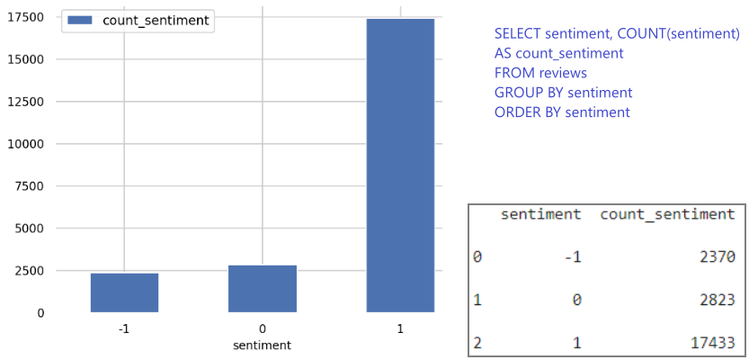

Figure 3.2.2.1 Sentiment Distribution: Review Count by Sentiment

(*The figure is created by Divyansh Soni through code implementation from “1 code-data transformation & data profiling (data distribution)”*)

We can see:

* There are 2,370 reviews labeled as "Negative" (sentiment score of -1).
* There are 2,823 reviews labeled as "Neutral" (sentiment score of 0).
* There are 17,433 reviews labeled as "Positive" (sentiment score of 1).

It's evident that positive reviews significantly outnumber negative and neutral ones, which appears favorable for the e-commerce company's business. We cannot consider it a significant imbalance among the classes. Hence, we will proceed with bias detection subsequently in section 3.2.3 to get more insights.

**(2) Sentiment Distribution Across Product Categories: Identifying the Highest Average Ratings**

It's important to consider the number of reviews in each category. A category with a high average sentiment score but a small number of reviews may not be as reliable as a category with a slightly lower score but a larger number of reviews. To understand which product categories are highest rated by average sentiment. We group the dataset by product category and calculate the average sentiment score for each category, compute the average sentiment score for each product category by taking the mean of the sentiment scores for all reviews within that category and then rank the product categories based on their average sentiment scores

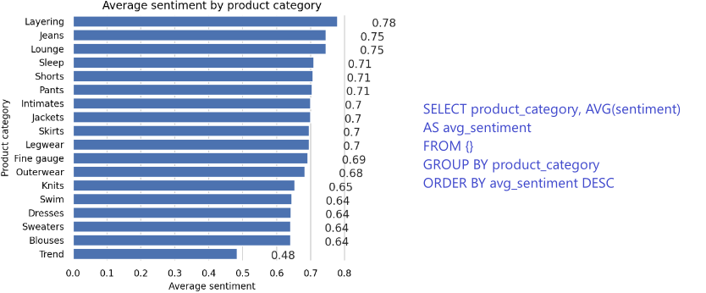

Figure 3.2.2.2 Sentiment Distribution Across Product Categories

(*The figure is created by Divyansh Soni through code implementation from “1 code-data transformation & data profiling (data distribution)”*)

**(3) Product Review Distribution: Analyzing Categories with the Most Reviews**

This information about which product categories have the most reviews can be valuable for understanding the popularity and engagement levels of different product categories within the dataset. It also provides context when analyzing sentiment distribution or identifying the highest-rated categories based on average sentiment. Below is the logic we find which product categories have the most reviews:

1. Aggregate Data by Product Category: Group the dataset by product category.
2. Count the Reviews: Calculate the total number of reviews for each product category.
3. Rank Product Categories by Review Count: Rank the product categories based on the total number of reviews. The categories with the highest review counts will be at the top of the ranking.

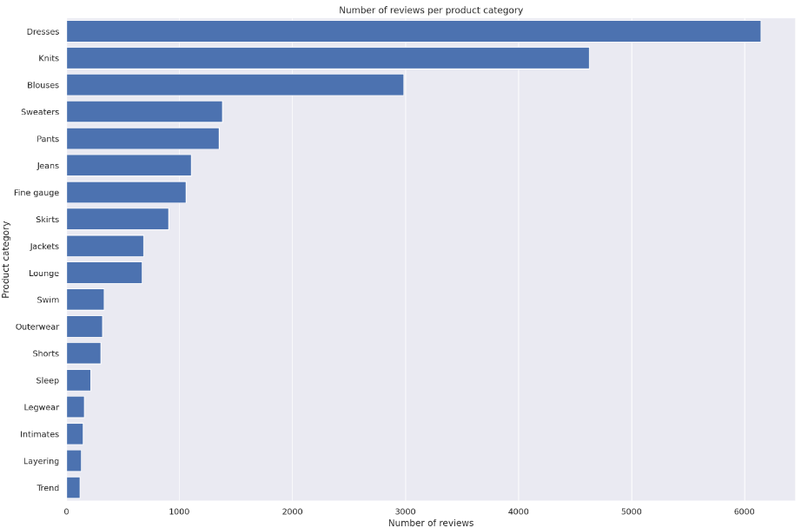

Figure 3.2.2.3 Sentiment Distribution (most reviews) Across Product Categories

(*The figure is created by Divyansh Soni through code implementation from “1 code-data transformation & data profiling (data distribution)”*)

**(4) Analyze the Distribution of Reviews per Sentiment per Category**

Visualizing the distribution of reviews per sentiment per category can enhance the understanding of how sentiments are distributed across various product categories, helping us identify any patterns or areas that may require further investigation or attention. Below is the logic we visualize the distribution of reviews per sentiment per category:

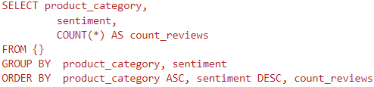

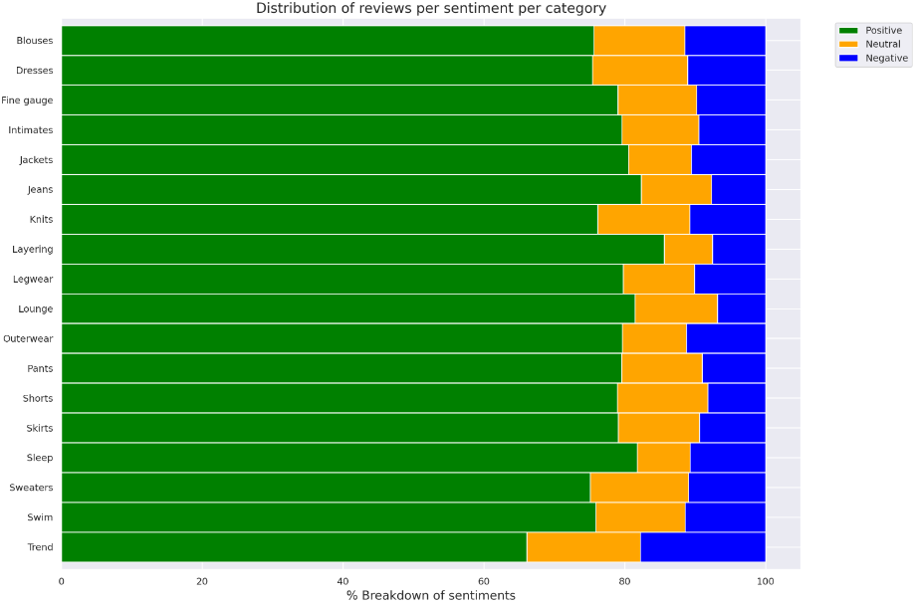

Figure 3.2.2.4 Distribution of Reviews per Sentiment per Category

(*The figure is created by Divyansh Soni through code implementation from “1 code-data transformation & data profiling (data distribution)”*)

### 3.2.3 Bias Detection and Analysis

The sentiment distribution: review count by sentiment in section 3.2.2 shows us that positive reviews significantly outnumber negative and neutral ones. For better visualization, we chose relatively small subset of data to visualize the occurring imbalances. We utilized the Seaborn library to create a count plot based on the 'sentiment' and 'product_category' columns.

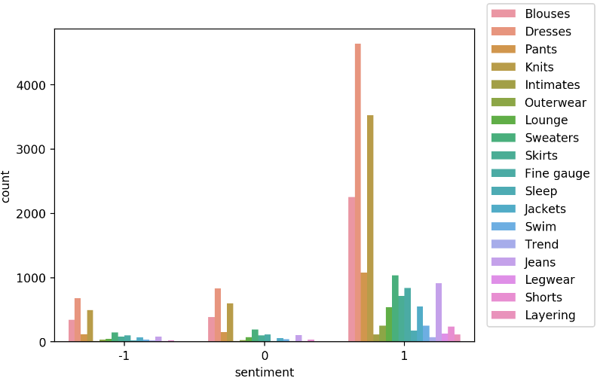

Figure 3.2.3.1 Distribution of Sentiments Across Product Categories

*(The figure is created by Divyansh Soni through code implementatio*n from “2 code-data profiling (bias detection)”)

We can see that there are way more positive reviews than negative or neutral. Such a dataset is called class imbalance. In the context of sentiment analysis or any classification task, an unbalanced dataset can pose challenges for machine learning models. Models trained on imbalanced datasets may become biased towards the majority class, leading to poor performance on minority classes. Visualizing class imbalances in a smaller subset of data can provide a quick and intuitive understanding of the distribution of classes. However, when working with larger datasets, conducting a more formal bias analysis becomes crucial. Bias detection and analysis involves a deeper investigation into how different classes are represented in the dataset, especially in the context of the real-world application. Below is the fundamental steps we do bias detection for conducting this big data machine learning syste on Amazon SageMaker platform:

**Step 1: Configure a DataConfig**

Provide information about the input data to the processor using the DataConfig of the Clarify container. This includes details about the dataset to be analyzed, such as the dataset file, its format, headers, and labels.

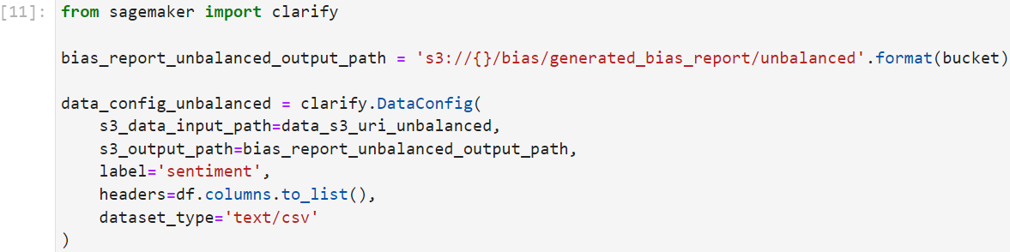

Figure 3.2.3.2 Configure a DataConfig

*(code implementation from “2 code-data profiling (bias detection)”, Divyansh Soni)*

**Step 2: Configure BiasConfig**

Measure bias by calculating a metric and comparing it across groups. Specify the required information in the BiasConfig API. SageMaker Clarify needs information on sensitive columns (facet_name) and desirable outcomes (label_values_or_threshold). For example, the sensitive facet may be product_category, and the desired outcome could be when sentiment==1.

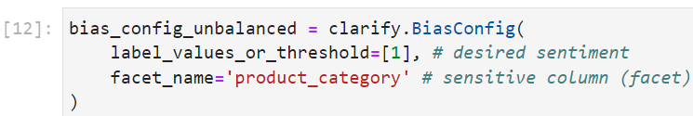

Figure 3.2.3.3 Configure BiasConfig

*(code implementation from “2 code-data profiling (bias detection)”, Divyansh Soni)*

**Step 3: Configure Amazon SageMaker Clarify as a Processing Job**

Construct a SageMakerClarifyProcessor object to scale the process of data bias detection. Set parameters such as instance_count (representing the number of nodes in the distributed cluster) and instance_type (specifying processing capability for each node, including compute and memory capacity).

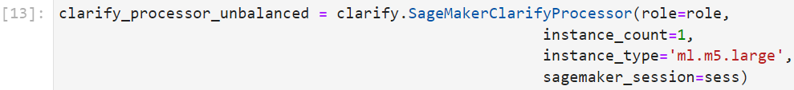

Figure 3.2.3.4 Configure Amazon SageMaker Clarify as a Processing Job

*(code implementation from “2 code-data profiling (bias detection)”, Divyansh Soni)*

**Step 4: Run the Amazon SageMaker Clarify Processing Job**

Execute the configured processing job to compute the requested bias metrics for the input data.

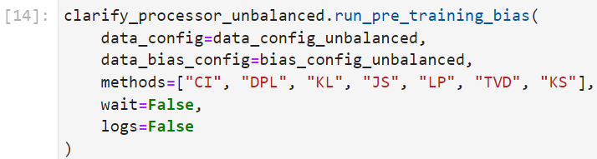

Figure 3.2.3.5 Amazon SageMaker Clarify Processing Job

*(code implementation from “2 code-data profiling (bias detection)”, Divyansh Soni)*

**Step 5: Output the Bias Report and Analysis**

Review and analyze the output, which typically includes a bias report covering various metrics related to bias. This report provides insights into the presence of bias in the dataset and helps in understanding and mitigating biases in the machine learning model. The bias report (unbalance) is uploaded to the submission with code scripts together.

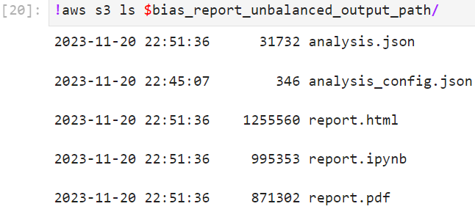

Figure 3.2.3.6 Bias Report and Analysis

(*The generated bias reports and analysis has been submitted together；code implementation from “2 code-data profiling (bias detection)”, Divyansh Soni*)

In the following code implementation, we addressed bias. We balance the dataset based on product_category and sentiment. The bias detection and analysis procedure after balancing the dataset by product_category and sentiment is the same as the fundamental steps used for bias detection. The bias report (balance) is included in the submission along with the code scripts. We have chosen not to provide additional bias analysis details in this section, as the generated reports are more detailed and comprehensive.

# 4 Train and Tune Models on Amazon SageMaker

In our pursuit of a robust big data machine learning system for product review sentiment analysis, we made strategic decisions to guide us on building a big data machine learning system. In Section 4.1, the spotlight shifted to hyperparameter tuning, comparing grid search and random search strategies. Opting for efficiency, scalability, and robustness, we selected Amazon SageMaker Automatic Model Tuning (AMT) with a random search strategy. In section 4.2, we conduct model training and evaluation on SageMaker Autopilot.

## 4.1 Hyperparameter Tuning

In the process of training models in a big data machine learning system, hyperparameter tuning emerges as a crucial step aimed at optimizing model performance. This optimization may entail achieving the highest accuracy or minimizing errors to attain the best quality model. However, hyperparameter tuning is typically a time-consuming and compute-intensive process (Bischl, Bernd, et al, 2023). There are some popular algorithms that can be used for automated model tuning, such as grid search algorithm, and random search algorithm (Zahedi, Leila, et al, 2021). The gid search algorithm and random search algorithm both work reasonably well in smaller search bases, also both fail fairly quickly when the search space grows beyond a certain size (Bischl, Bernd, et al, 2023). The grid search algorithm tests every combination by training the model with each set of hyperparameters and selecting the best possible parameters. The advantage of grid search is that it enables us to explore all potential combinations. This approach works particularly well when dealing with a small number of hyperparameters and a limited range of values to explore for each hyperparameter. Nevertheless, as the number of hyperparameters or the range of values to explore for these hyperparameters increases, this process can become significantly time-consuming (Alibrahim, Hussain, and Simone A. Ludwig, 2021). In random search, it begins by defining sets of available hyperparameters, comprising the names and values we wish to explore. Instead of exhaustively searching every combination, the algorithm randomly selects hyperparameter values within the defined search space (Zahedi, Leila, et al, 2021). Additionally, stop criteria in the random search strategy, such as elapsed time or a maximum number of completed pieces of training, can be specified. When the stop criteria are met, we select the best-performing set of hyperparameters from the trained models available so far. There are some of the key advantages of random search over grid search for hyperparameter tuning in big data machine learning (Alibrahim, Hussain, and Simone A. Ludwig, 2021):

* Efficiency: Random search significantly reduces the computational cost of hyperparameter tuning, making it more suitable for large-scale problems.
* Scalability: Random search can effectively handle high-dimensional hyperparameter spaces, which often arise in big data machine learning tasks.
* Exploration: Random search avoids the potential biases introduced by the predefined grid in grid search, allowing for a more comprehensive exploration of the hyperparameter space.
* Flexibility: Random search can be easily adapted to different hyperparameter distributions, making it more versatile for various machine learning models.
* Robustness: Random search is less prone to overfitting and local optima compared to grid search, leading to more generalizable models.

By comparing the grid search algorithm, we find that random search is more efficient and less computationally expensive, especially when dealing with large datasets and high-dimensional hyperparameter spaces (Alibrahim, Hussain, and Simone A. Ludwig, 2021). And we don’t have the need to test every combination by training the model with each set of hyperparameters.

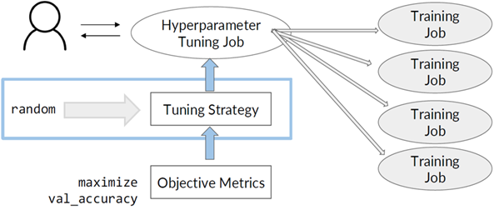

Figure 4.1.1 Hyperparameter Tuning Using Random Search

Amazon SageMaker Automatic Model Tuning (AMT) is a comprehensively managed platform designed for large-scale gradient-free function optimization (Perrone, Valerio, et al, 2021). We can use AMT to do hyperparameter tuning at scale and find the best version of the model by running multiple training jobs on the dataset using the hyperparameter range values that we specify. For tuning strategies, SageMaker natively supports random optimization strategies. By the comparison of grid search and random search, we opted to use the random search supported by Amazon SageMaker for hyperparameter tuning. Here are the steps we do hyperparameter tuning

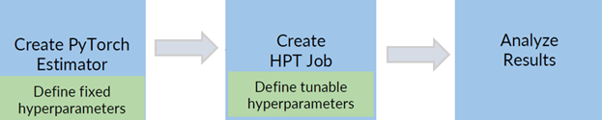

Figure 4.1.2 Basic Steps for Hyperparameter Tuning on SageMaker

**Step 1. Create PyTorch Estimator (Define fixed hyperparameters)**

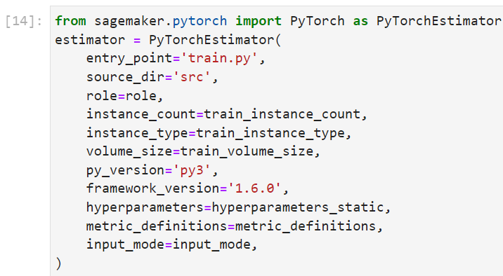

Figure 4.1.3 Create PyTorch Estimator

*(code implementation from “3 code-hyperparameter tuning”, Divyansh Soni)*

Include specific parameters from this set in the hyperparameters argument for both the PyTorch estimator and tuner. Set up the dictionary for the parameters to be included in the hyperparameters argument

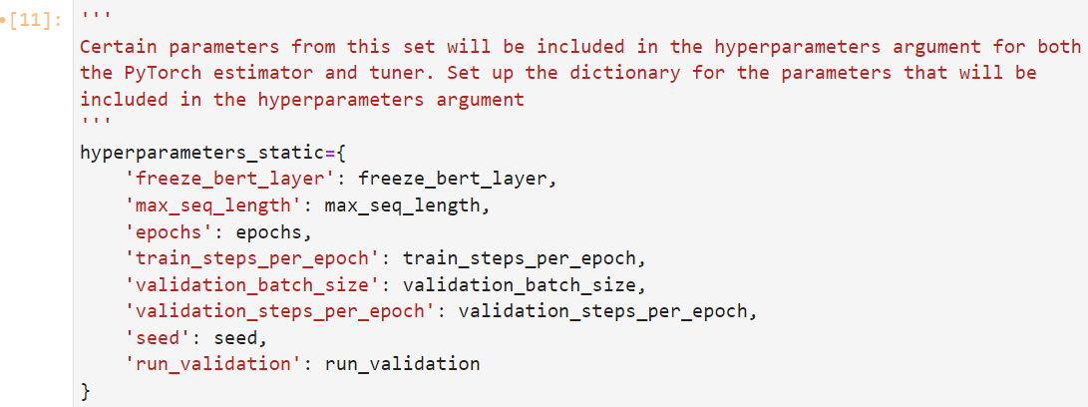

Figure 4.1.4 Configure Hyperparameter Tuning Job-Part of the Key Codes

*(code implementation from “3 code-hyperparameter tuning”, Divyansh Soni)*

Employ a Random search strategy to identify combinations of hyperparameters, within defined ranges, for each training job within the tuning process. Upon completion of the tuning job, we can choose the hyperparameters employed by the top-performing training job with respect to the objective metric.

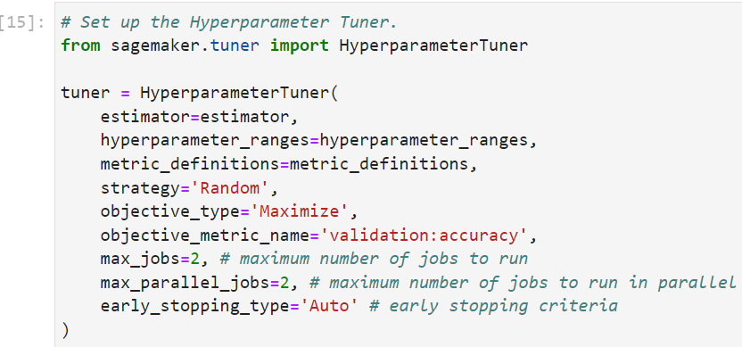

Figure 4.1.5 Employ a Random Search Strategy -Part of the Key Codes

*(code implementation from “3 code-hyperparameter tuning”, Divyansh Soni)*

**Step2. Create Hyperparameter Tuning Job**

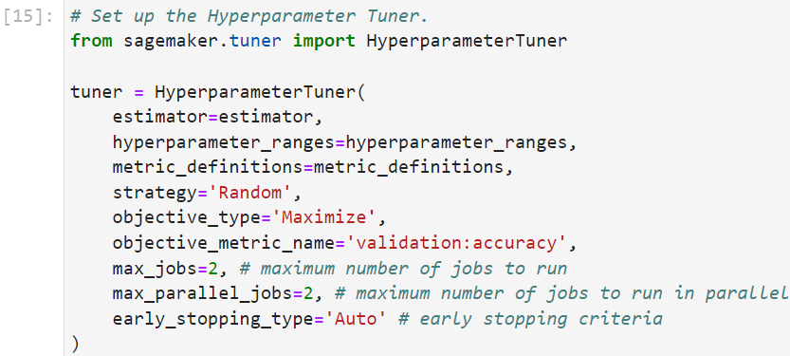

Figure 4.1.6 Create Hyperparameter Tuning Job

*(code implementation from “3 code-hyperparameter tuning”, Divyansh Soni)*

**Step 3. Analyze Results**

The outcomes of the SageMaker Hyperparameter Tuning Job can be accessed through the analytics of the tuner object. Utilizing the dataframe function directly converts the results into a dataframe.

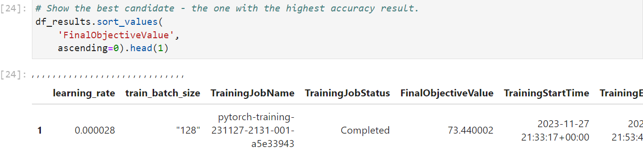

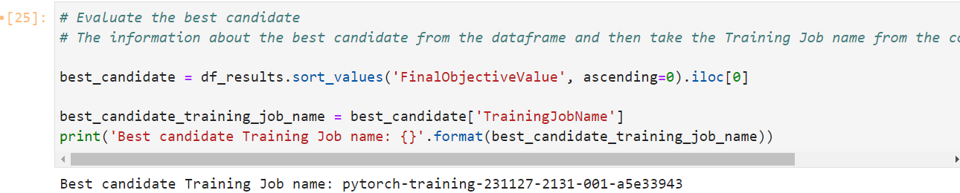

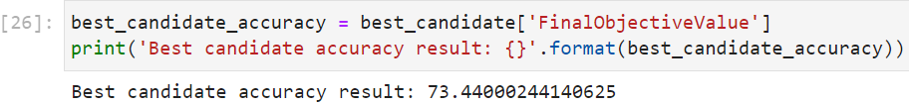

Figure 4.1.7 Analyze Results

*(code implementation from “3 code-hyperparameter tuning”, Divyansh Soni)*

In the context of large-scale training and tuning, ongoing monitoring and selecting appropriate compute resources are crucial. Although we have the flexibility to opt for various compute options, determining the specific instance types and sizes requires a case-by-case approach. There is no one-size-fits-all solution; it hinges on comprehending the workload and conducting empirical testing to ascertain the optimal compute resources for the training process until we get the best candidate values. By performing a random search for hyperparameter tuning through the SageMaker Hyper-Parameter Tuning (HPT) Job on ml.c5.9xlarge, we can monitor the status of the tuning job and identify the hyperparameter configuration that yields the best candidate accuracy result, which is 73.44%. This section represents an additional research exploration into conducting hyperparameter tuning at scale. In the next section, we will delve into and implement how to scale up model training and evaluate the accuracy of models within this big data machine learning system.

## 4.2 Model Training, Model Evaluation

The process of model training and validation involves numerous iterations across various experiments. The objective is to identify the optimal combination of data, algorithm, and hyperparameters that yields the most effective model. For each selected combination, the model is trained and assessed against a designated holdout dataset.

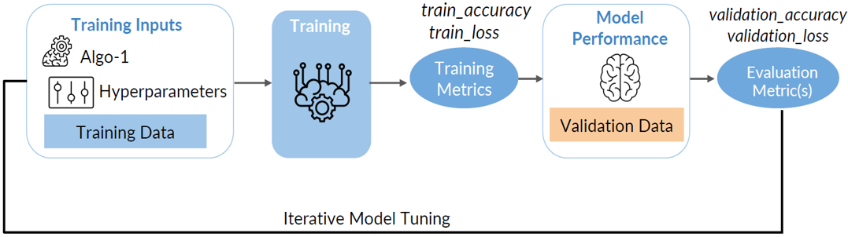

Figure 4.2.1 The Cycle of Iterative Model Tuning

This cycle is repeated iteratively until a well-performing model is achieved based on the defined objective metric. Performing these iterations can be computationally intensive, and it is crucial to facilitate rapid iterations without encountering bottlenecks. The AutoML capabilities significantly alleviate the repetitive tasks associated with constructing and fine-tuning models, streamlining the extensive iterations and experiments usually necessary in the process ((Salehin, Imrus, et al., 2023)). Sagemaker Autopilot, Amazon Sagemaker's AutoML implementation, not only automates the machine learning workflow but also provides a high degree of control and transparency (SageMaker Autopilot, 2023).

Autopilot ensures complete transparency by automatically generating and sharing feature engineering code. It produces Jupiter notebooks that guide us through the entire model-building process, covering data processing, algorithms, hyperparameters, and training configuration. These automatically generated notebooks can be used to replicate the experiment or make modifications for ongoing model refinement (SageMaker Autopilot, 2023). This allows us to comprehend the precise details of data processing and model construction.

Here is the workflow that we conduct a big data machine learning system on Amazon SageMaker. We’ve completed data ingestion, data analysis by data profiling, preparation and transformation in previous section/steps. In this subsection, we focus on model training and tuning.

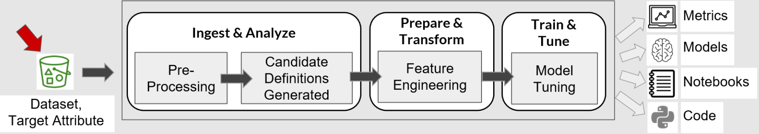

Figure 4.2.2 Amazon SageMaker Autopilot Workflow

Below is the fundemental steps we train models and tune models on Amazon SageMaker Autopilot.

**Step 1. Load Transformed Data Set**

The data set has been processed in the previous steps. We directly load it in the SageMaker Lab development environment.

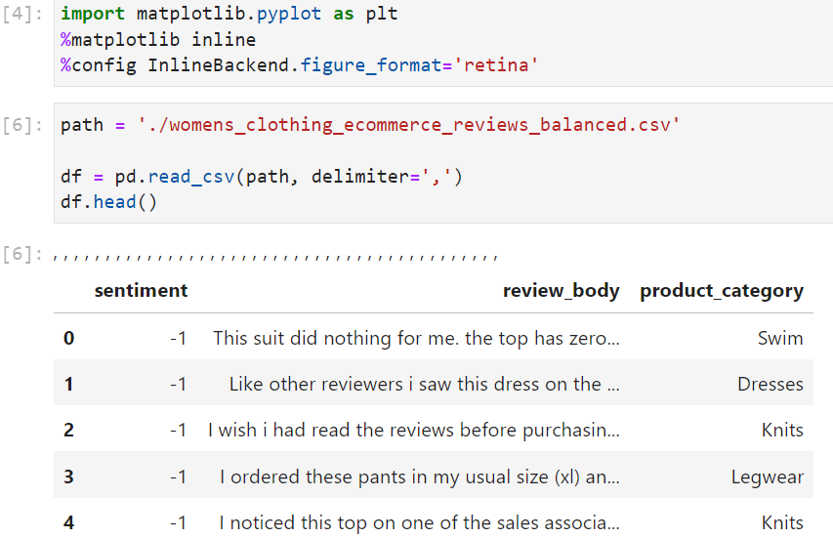

Figure 4.2.3 Load Data Set

*(code implementation from “4 code-model training and tuning on SageMaker Autopilot”, Divyansh Soni)*

**Step 2. Set up and Initiate the Autopilot job**

Setting up and initiating the Autopilot job in Amazon SageMaker involves configuring the job with the necessary information and parameters

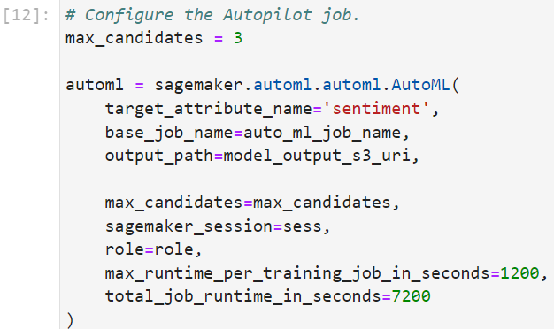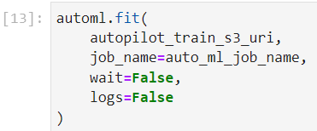

Figure 4.2.4 Set up the Autopilot Job

*(code implementation from “4 code-model training and tuning on SageMaker Autopilot”, Divyansh Soni)*

**Step 3. Monitor the Progress of the Autopilot Job**

Monitoring the progress of the Autopilot job is crucial to understanding how different models and hyperparameter configurations are being explored. In SageMaker, we can use the SDK capabilities to access insights, logs, and analytics during the Autopilot job execution. After initiating the Autopilot job, we monitor its progress directly from the notebook using the SDK capabilities.

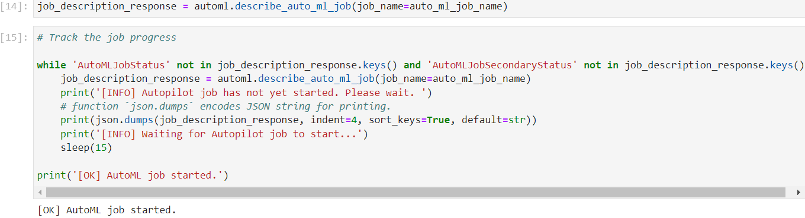

Figure 4.2.5 Monitor the Progress of the Autopilot Job

We can review the processing jobs and track their progress on SageMaker platform through user-friendly interfaces:

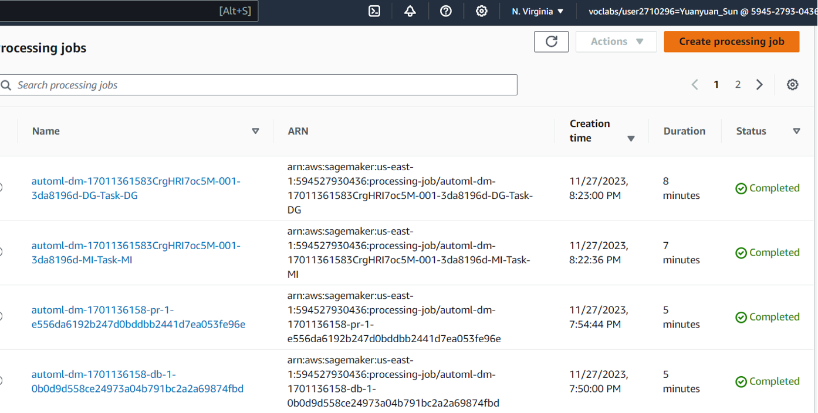

Figure 4.2.6 User-friendly Interfaces of Processing Jobs on SageMaker

In this step, SageMaker AutoPilot produces two notebooks: Data Exploration, Candidate Definition.

* Data Exploration Notebook: This notebook provides an overview of the data, including its basic statistics, distribution of features, and relationships between features. It also identifies potential data quality issues, such as missing values and outliers.
* Candidate Definition Notebook: This notebook defines the different machine learning pipelines that Autopilot will evaluate for the task. Each pipeline consists of a set of preprocessing steps, an algorithm, and a set of hyperparameter values. Autopilot will train and evaluate each pipeline on the data and select the best one based on its performance.

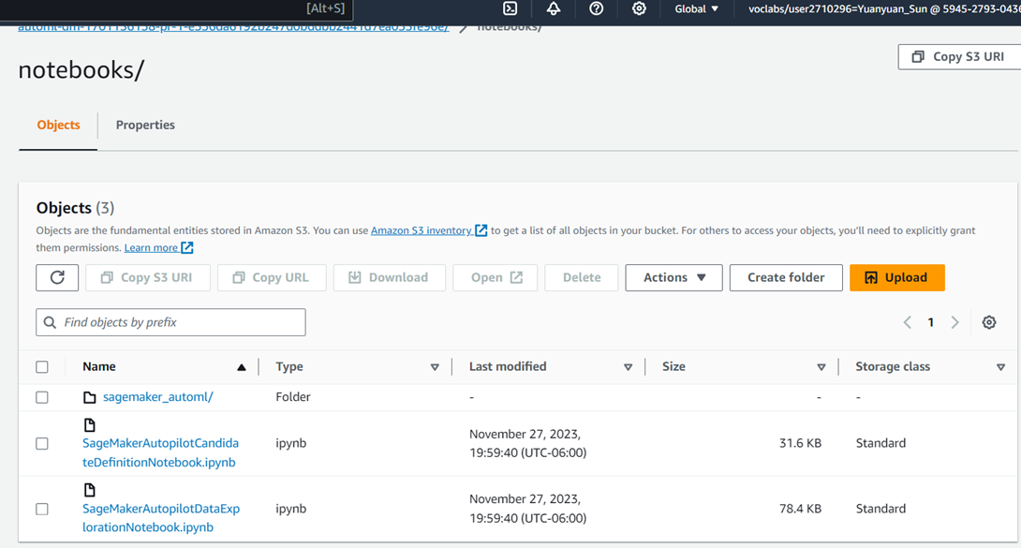

Figure 4.2.7 Two Notebooks Produced by SageMaker AutoPilot

**Step 4. Feature Engineering**

The feature engineering step can be identified by checking the job status values. Specifically, we've mentioned the primary job status value InProgress and the secondary job status value FeatureEngineering. The primary job status (AutoMLJobStatus) being in the state InProgress indicates that the Autopilot job is actively running. Additionally, the secondary job status (AutoMLJobSecondaryStatus) being FeatureEngineering specifically signifies that the Autopilot job is in the feature engineering phase. This is a good approach to monitor and wait for the completion of the feature engineering step before proceeding with the next phases of the Autopilot job.

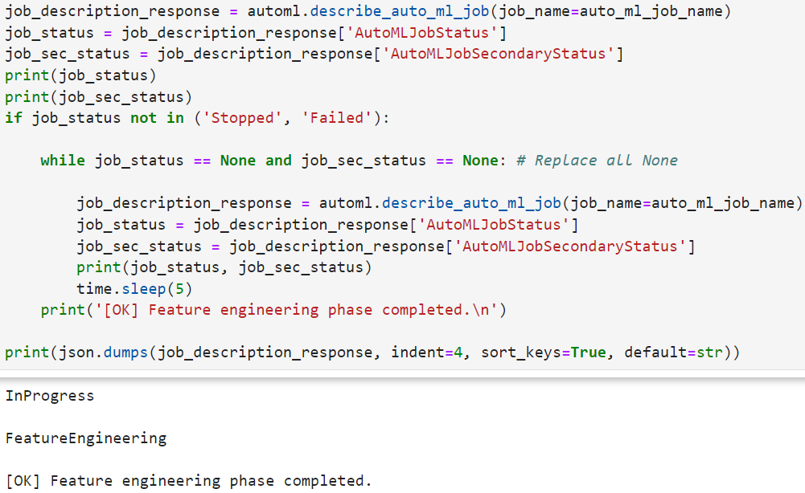

Figure 4.2.8 Feature Engineering Verification

**Step 5. Training and Tuning the Model**

SageMaker Autopilot and the fact that it automates the end-to-end process of building, training, and deploying machine learning models. It emphasizes the goal of making machine learning more accessible to users without extensive expertise by automating tasks. We can verify the completion of the model tuning phase via below code:

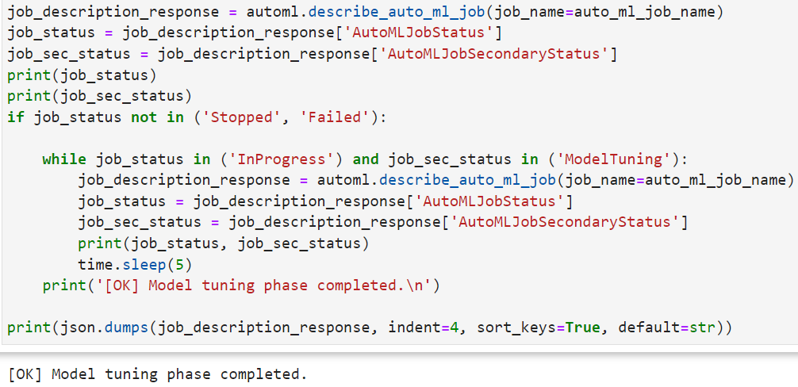

Figure 4.2.9 Training and Tuning the Model

*(code implementation from “4 code-model training and tuning on SageMaker Autopilot”, Divyansh Soni)*

**Step 5. Evaluating Output**

We have successfully concluded the Autopilot job on the dataset and visualized the trials, we can now retrieve information about the best candidate model and review its details.

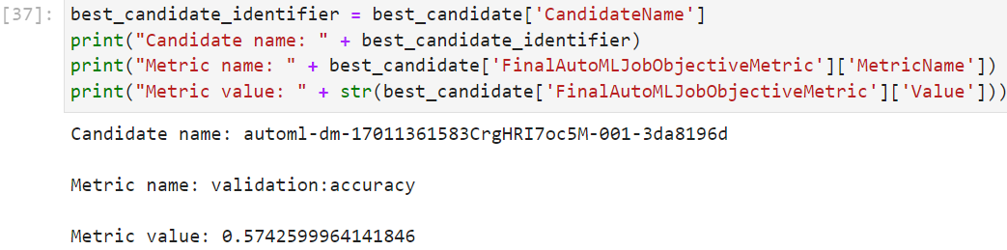

Figure 4.2.10 Evaluating Output

Above is the best candidate model generated by SageMaker Autopilot:

* Candidate Name: automl-dm-17011361583CrgHRI7oc5M-001-3da8196d

This is the name assigned to one of the candidate models generated by SageMaker Autopilot. Each candidate represents a different combination of hyperparameters and model architecture explored during the automated machine learning process.

* Metric Name: validation:accuracy

This indicates the evaluation metric used for assessing the performance of the candidate model. In this case, the metric is accuracy, which measures the proportion of correctly classified instances in the validation set.

* Metric Value: 0.5742599964141846

The metric value represents the actual performance of the candidate model with respect to the specified metric. In this instance, the accuracy of the model on the validation set is approximately 57.4%.

Below is the artifacts generated by Autopilot including the following, we've downloaded some of the output documents and will submit them on Blackboard together:

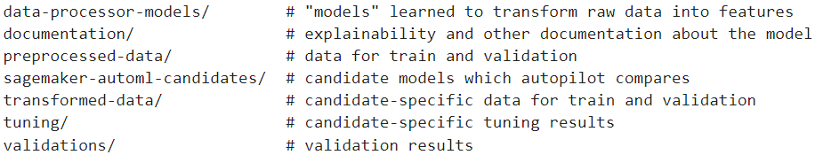

Figure 4.2.11 The Artifacts Generated by Autopilot

# 

# 5. Summary

A robust big data machine learning system for sentiment analysis of product reviews has been successfully developed and implemented. Leveraging cutting-edge technologies and methodologies, the system demonstrates a commitment to efficiency, scalability, and accuracy in handling extensive datasets. We successfully demonstrated the feasibility of building a big data machine learning system for product review sentiment analysis by conducting a comparative analysis to choose appropriate technologies. Additionally, we performed data profiling using AWS Glue and AWS Athena, conducted bias detection using Amazon SageMaker Clarify, and carried out model tuning and training with Amazon SageMaker Autopilot. The system achieved promising results, and further enhancements can be achieved by refining the data preparation and preprocessing steps, exploring additional machine learning algorithms, and optimizing the hyperparameters.

# Reference

[1] Alibrahim, Hussain, and Simone A. Ludwig. ‘Hyperparameter Optimization: Comparing Genetic Algorithm against Grid Search and Bayesian Optimization’. *2021 IEEE Congress on Evolutionary Computation (CEC)*, IEEE, 2021, pp. 1551–59. *DOI.org (Crossref)*,<https://doi.org/10.1109/CEC45853.2021.9504761>.

[2] Bischl, Bernd, et al. ‘Hyperparameter Optimization: Foundations, Algorithms, Best Practices, and Open Challenges’. *WIREs Data Mining and Knowledge Discovery*, vol. 13, no. 2, Mar. 2023, p. e1484. *DOI.org (Crossref)*,<https://doi.org/10.1002/widm.1484>.

[3] Perrone, Valerio, et al. ‘Amazon SageMaker Automatic Model Tuning: Scalable Gradient-Free Optimization’. *Proceedings of the 27th ACM SIGKDD Conference on Knowledge Discovery & Data Mining*, ACM, 2021, pp. 3463–71. *DOI.org (Crossref)*,<https://doi.org/10.1145/3447548.3467098>.

[4] Zahedi, Leila, et al. *Search Algorithms for Automated Hyper-Parameter Tuning*. arXiv:2104.14677, arXiv, 29 Apr. 2021. *arXiv.org*,<http://arxiv.org/abs/2104.14677>.

[5] Brumbaugh, Eli, et al. ‘Bighead: A Framework-Agnostic, End-to-End Machine Learning Platform’. *2019 IEEE International Conference on Data Science and Advanced Analytics (DSAA)*, IEEE, 2019, pp. 551–60. *DOI.org (Crossref)*, <https://doi.org/10.1109/DSAA.2019.00070>.

[6] Feng, Z. (2023). Past and Present of Natural Language Processing. In: Formal Analysis for Natural Language Processing: A Handbook. Springer, Singapore.<https://doi.org/10.1007/978-981-16-5172-4_1>

[7] Black, Anne C., et al. ‘Missing Data Techniques for Multilevel Data: Implications of Model Misspecification’. *Journal of Applied Statistics*, vol. 38, no. 9, Sept. 2011, pp. 1845–65. *DOI.org (Crossref)*,<https://doi.org/10.1080/02664763.2010.529882>.

[8] Branco, Paula, et al. ‘A Survey of Predictive Modeling on Imbalanced Domains’. *ACM Computing Surveys*, vol. 49, no. 2, June 2017, pp. 1–50. *DOI.org (Crossref)*,<https://doi.org/10.1145/2907070>.

[9] Das, Sanjiv, et al. ‘Fairness Measures for Machine Learning in Finance’. *The Journal of Financial Data Science*, vol. 3, no. 4, Oct. 2021, pp. 33–64. *DOI.org (Crossref)*,<https://doi.org/10.3905/jfds.2021.1.075>.

[10] Luque, Amalia, et al. ‘The Impact of Class Imbalance in Classification Performance Metrics Based on the Binary Confusion Matrix’. *Pattern Recognition*, vol. 91, July 2019, pp. 216–31. *DOI.org (Crossref)*,<https://doi.org/10.1016/j.patcog.2019.02.023>

[11] K, Valantis. ‘Battle of The Giants: TensorFlow vs PyTorch 2023’. *Medium*, 28 Jan. 2023, <https://medium.com/@valkont/battle-of-the-giants-tensorflow-vs-pytorch-2023-fd8274210a38>

[12] ‘PyTorch’. Wikipedia, 4 Nov. 2023. Wikipedia, <https://en.wikipedia.org/w/index.php?title=PyTorch&oldid=1183408410>.

[13] ‘TensorFlow’. Wikipedia, 10 Sept. 2023. Wikipedia, <https://en.wikipedia.org/w/index.php?title=TensorFlow&oldid=1174808074>.

[14] ‘Bias Detection and Model Explainability – Amazon Web Services’. Amazon Web Services, Inc., https://aws.amazon.com/sagemaker/clarify/. Accessed 20 Nov. 2023.

[15] ‘Data Profiling’. Wikipedia, 4 Aug. 2022. Wikipedia, https://en.wikipedia.org/w/index.php?title=Data_profiling&oldid=1102297638.

[16] MLlib | Apache Spark. https://spark.apache.org/mllib/. Accessed 20 Nov. 2023.

[17] ‘Prepare Data For Ml, Data Wrangling Tool - Amazon SageMaker Data Wrangler - AWS’. Amazon Web Services, Inc., https://aws.amazon.com/sagemaker/data-wrangler/. Accessed 20 Nov. 2023.

[18] Singh, Aishwarya. ‘Ultimate Guide to Handle Big Datasets for Machine Learning Using Dask (in Python)’. Analytics Vidhya, 9 Aug. 2018, <https://www.analyticsvidhya.com/blog/2018/08/dask-big-datasets-machine_learning-python/>.

[19] SageMaker Autopilot - Amazon SageMaker. https://docs.aws.amazon.com/sagemaker/latest/dg/autopilot-automate-model-development.html. Accessed 29 Nov. 2023.

[20] Salehin, Imrus, et al. ‘AutoML: A Systematic Review on Automated Machine Learning with Neural Architecture Search’. Journal of Information and Intelligence, Oct. 2023, p. S2949715923000604. DOI.org (Crossref), <https://doi.org/10.1016/j.jiixd.2023.10.002>.

[21] Integration with AWS Glue - Amazon Athena. https://docs.aws.amazon.com/athena/latest/ug/glue-athena.html. Accessed 3 Dec. 2023.